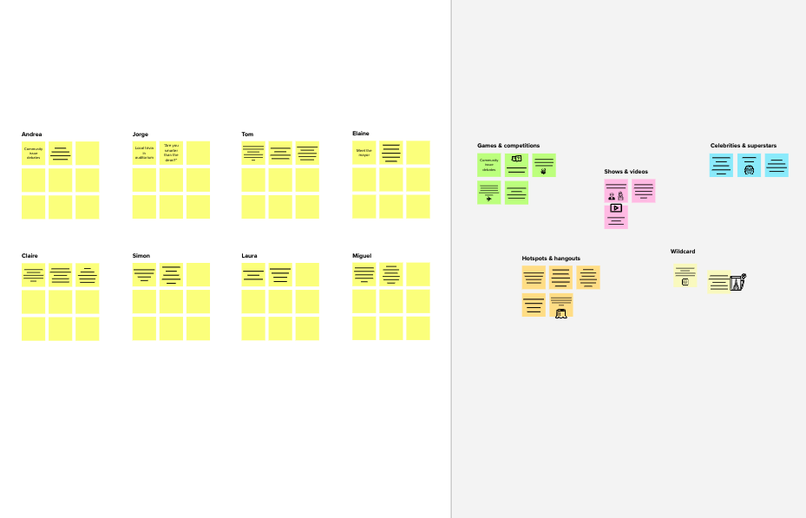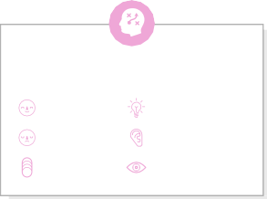

# Brainstorm

**TIP**

You can select a sticky note and hit the pencil [switch to sketch] icon to start drawing!

## Before you collaborate

A little bit of preparation goes a long way with this session. Here’s what you need to do to get going.

**10 minutes**

**1**

## Define your problem statement

What problem are you trying to solve? Frame your problem as a How Might We statement. This will be the focus of your brainstorm.

**5 minutes**

**2**

## Brainstorm

Write down any ideas that come to mind that address your problem statement.

**10 minutes**

**3**

## Group ideas

Take turns sharing your ideas while clustering similar or related notes as you go. Once all sticky notes have been grouped, give each cluster a sentence-like label. If a cluster is bigger than six sticky notes, try and see if you and break it up into smaller sub-groups.

**20 minutes**

**4**

## Prioritize

Your team should all be on the same page about what's important moving forward. Place your ideas on this grid to determine which ideas are important and which are feasible.

**20 minutes**

## After you collaborate

You can export the mural as an image or pdf to share with members of your company who might find it helpful.

**Quick add-ons**

# & idea prioritization

|  |  |  |  |  |  |  |
| --- | --- | --- | --- | --- | --- | --- |
|  | | | | | | |
|  | Crop Performance Analysis | Protection from insects for high yields and quality |  | preventing vulnerable to attack | High Quality of Crop Production |  |
| High Quality of Crop Production |  |  | Crop Protection After the Cultivation |  | 24X7  Monitoring Crops |
|  | Unique Irrigation System |  | organic and synthetic pesticide use | Control of animal pests of crops |  |
| lowering Usage of Pestisides |  | Using Neon light for the crops |  |  | Control of weeds and integrated management |
|  | **TIP**  Participants can use th cursors to point at wh sticky notes should go the grid. The facilitato confirm the spot by us the laser pointer holdi **H key** on the keyboar | eir ere on  r can ing  ng the  d. | Lowering Water Consumption |  |  |
|  |  |  |  | Plant Disease Management |  |

1. **Team gathering**

**SHEIK RIYAS**

**PARTHIBAN S**

**SHYAM B**

**ADHITHIYAN D**

**TIP**

Add customizable tags to sticky notes to make it easier to find, browse, organize, and categorize important ideas as themes within your mural.

Define who should participate in the session and send an invite. Share relevant information or pre-work ahead.

Unique

**PROBLEM**

**How might we Protect Crops?**

24X7

crop

lowering

field

Crop Protection

Enhance the effectiveness

Control of animal

Control of

Crop

Using Neon

**A Share the mural**

**Share a view link** to the mural with stakeholders to keep

Irrigation

Monitoring

Power

Usage of

of crop

weeds and

Performance light for the

### Use this template in your own brainstorming sessions so your team

1. **Set the goal**

System

organic and synthetic

Crops

Spraying weedicides

rotation

Plant Disease

Consumption

Lowering Water

Pestisides

Saving

monitoring,

High Quality of

After the

Cultivation

Seed

protection products

Protection from insects

pests of

crops

Control of diseases of crop

integrated

management

Economic

Analysis

preventing vulnerable

crops

plant crop varieties that

them in the loop about the outcomes of the session.

**Export the mural**

pesticide use

on the

Management

Consumption

Expenditure

Crop

Treatment

for high yields plants caused by

considerations

are resistant **B**

### can unleash their imagination and start shaping concepts even if you're not sitting in the same room.

**10 minutes** to prepare

**1 hour** to collaborate

**2-8 people** recommended

Think about the problem you'll be focusing on solving in

the brainstorming session.

1. **Learn how to use the facilitation tools**

Use the Facilitation Superpowers to run a happy and productive session.

[**Open article**](https://support.mural.co/en/articles/2113740-facilitation-superpowers)

#### Key rules of brainstorming

To run an smooth and productive session

weeds

Production

and quality

microorganisms

to attack

to attack

preventing vulnerable to attack

|  |  |
| --- | --- |
| Unique Irrigation System | 24X7  Monitoring Crops |
| organic and synthetic pesticide use | Plant Disease Management |

Using Neon light for the crops

Lowering Water Consumption

field monitoring,

lowering Usage of Pestisides

High Quality of Crop Production

Crop Performance Analysis

Crop Protection After the Cultivation

Protection from insects for high yields and quality

Control of animal pests of crops

Control of weeds and integrated management

Export a copy of the mural as a PNG or PDF to attach to emails, include in slides, or save in your drive.

#### Keep moving forward

**Strategy blueprint**

Define the components of a new idea or strategy.

[**Open the template**](https://app.mural.co/template/e95f612a-f72a-4772-bc48-545aaa04e0c9/984865a6-0a96-4472-a48d-47639307b3ca)

**Customer experience journey map**

Stay in topic. Defer judgment.

Encourage wild ideas. Listen to others.

#### Importance

If each of these

Understand customer needs, motivations, and obstacles for an experience.

[**Open the template**](https://app.mural.co/template/b7114010-3a67-4d63-a51d-6f2cedc9633f/c1b465ab-57af-4624-8faf-ebb312edc0eb)

[**Share template feedback**](https://muralco.typeform.com/to/CiqaHVat?typeform-source=app.mural.co)

Go for volume. If possible, be visual.

tasks could get

done without any difficulty or cost, which would have the most positive impact?

#### Feasibility

Regardless of their importance, which tasks are more feasible than others? (Cost, time, effort, complexity, etc.)

**Strengths, weaknesses, opportunities & threats**

Identify strengths, weaknesses, opportunities, and threats (SWOT) to develop a plan.

[**Open the template**](https://app.mural.co/template/6a062671-89ee-4b76-9409-2603d8b098be/ca270343-1d54-4952-9d8c-fbc303ffd0f2)

[**Share template feedback**](https://muralco.typeform.com/to/CiqaHVat?typeform-source=app.mural.co)

**Template**

**Need some inspiration?**

See a finished version of this template to kickstart your work.

[**Open example**](https://app.mural.co/template/e5a93b7b-49f2-48c9-afd7-a635d860eba6/93f1b98d-b2d2-4695-8e85-7e9c0d2fd9b9)